Problem1:

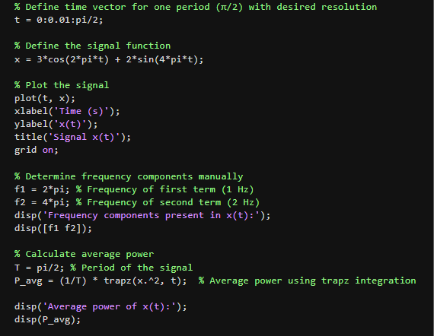

1. 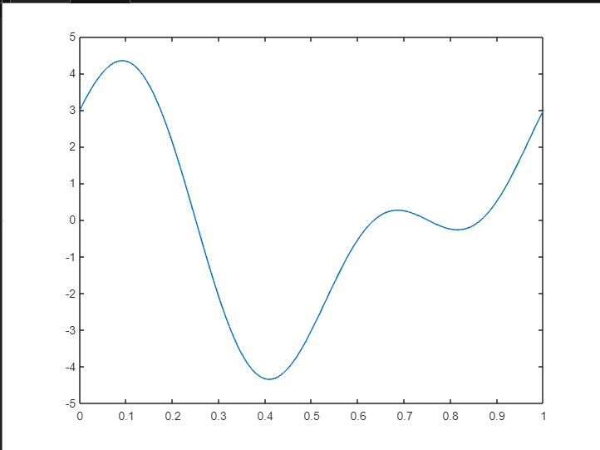
2. Frequency components present in x(t): 6.2832 12.5664
3. Average power of x(t): -6.6562

Problem 2:

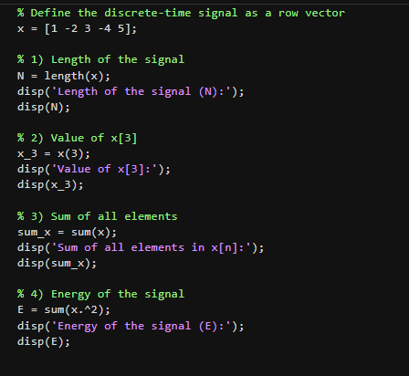

1. Length of the signal (N) : 5

2) Value of x[3]: 3

3) Sum of all elements in x[n]: 3

1. Energy of the signal (E): 55